INTRODUTION
OVERVIEW
- Our team’s alloted project is BUSSINUSS CARD We all work togetherand designed this project
PURPOSE
- We designed this project to promote our/my business to the customers

PROBLEM DEFINITION & DESIGN THINKING
EMPATHY MAP:
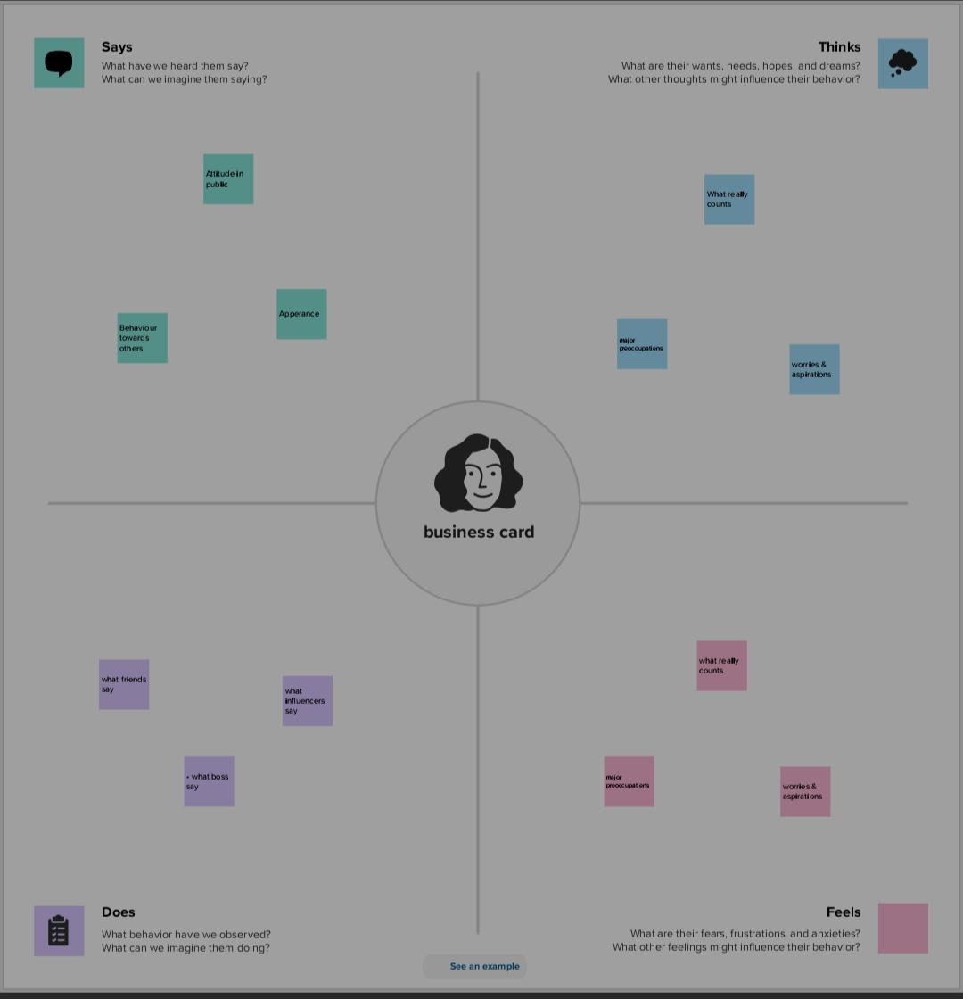
BRAIN STROM :
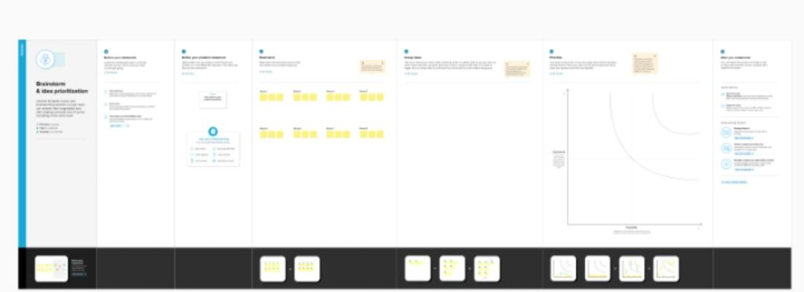

RESULT


ADVANTAGES & DISADVANTAGE
- Our business can reach the people easily this can improve our business
- Iliterate may not understand

APPLICATION:
It have develop my business

CONCLUSION:
With help of canva app we have design our project successful

